Hardware Abstraction Layers, LabVIEW, and TestStand

Simple Scope HAL

Benefits of Hardware Abstraction Layers:

Reuse Code: Coding a Hardware Abstraction Layer (HAL) in an object oriented programming language allows the developer to leverage inheritance. Often, many functions/methods only need to be coded once, in the parent class. Then, any child class can reuse that code.

Design a public interface to the class: In LabVIEW, the attributes of the class are scoped as private, as such the developer of the class creates the public interface (methods) to access the attributes.

Add functionality without changing the main.vi: If carefully designed, the main code calls only parent methods or dynamic dispatch methods. New child classes can be written and tested outside of the main code. Then with a factory pattern, they can be accessed from the main.vi without any changes to main.vi

The goal behind the hardware abstraction layer (HAL) is to deploy modular code such that an engineer can replace a piece of hardware in a test system and not be required to rewrite any code. Additionally, conditions may require that the executable code run 24/7 with no rebuild of the executable during the hardware exchange.

Equally of value, is the modularity of a well designed HAL.

Abstraction layers provide benefits beyond the exchange of hardware. A software developer may determine that an abstraction layer and plug-in design may provide the necessary scalability to add different analysis functions for data or reporting of that data. The key benefit is the ability to have a “family” of functionality that can be extended without the added expense of the software developer being required to modify the main body of code.

OO’s importance in the HAL:

Object oriented (OO) programming includes a concept known as “inheritance.” Inheritance provides the ability to reuse code within a family of classes. The OO novice can think of the class as a library of functions. Functions in OO are called methods.

The following is a UML (Unified Modeling Language) Class Diagram. There is one parent class and two child classes. This would be analogous to 3 different libraries.

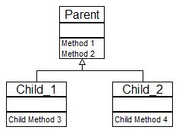

Once Method 1 and Method 2 have been coded at the parent level, this code can be reused by any child class. Additionally, the Child classes may extend the functionality of the Parent with additional methods.

A Simple Scope HAL
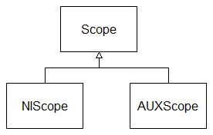

A HAL will include a parent class such as “Scope” and child classes such as “NIScope” and “AUXScope”

The development team then determines the rest of the design. There are many options for the design. First the developers look for functions or methods that would be reused accoss all of the child classes and include those at the parent level so that they can be reused. Second, the developers define the public interface to the class and include all dynamic dispatch (overriding) methods at the parent level. Third, the developers determine what will be included in the class private data. A first pass at a simple scope HAL may resemble the following:

Typical class attributes for a HAL might include: resource name, vertical setting, mode etc. In the diagram above, the NIScope class will have 2 attributes: Resource Name and Number of Channels. NIScope has its own attribute and inherits an additional attribute from its parent class. AUXScope will have only one attribute.

Methods are the actions that are performed by the class. The child methods also inherits from the parent class. As such the NIScope class has 5 methods that it can execute. Inheritance facilitates code reuse by allowing the child class to use parent methods. So NIScope and AUXScope can call reset. Reset never has to be rewritten.

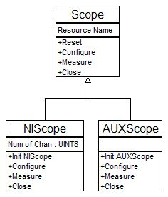

Generating the HAL Framework From the UML

There are several options for using tools to generate the LabVIEW HAL framework from the UML Class Diagram. The tool below will read the class diagram and create the shell code in the project. Note also that options exist to keep the UML in sync with the LabVIEW code as the developers code and extend the classes.
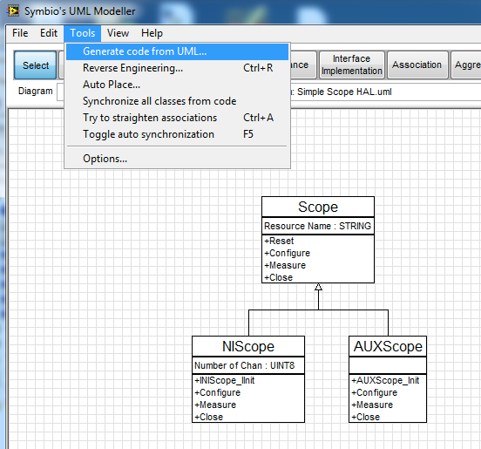

This is the project that was created from the code generation tool. The next step is to then add the functionality to the method shells that were generated.
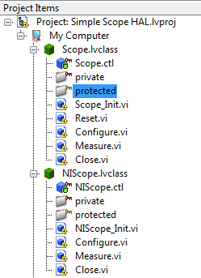

Calling the HAL From The Main.vi

In this simplistic example below the dynamic dispatch section is written with the public interface defined at the parent class. As run time, the appropriate scope will be selected and either the NIScope will execute the series of steps or the AUXScope will execute. The elegance of this design is that the main code does not change as new scopes are added to the overall project.

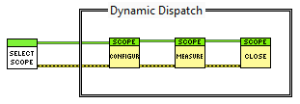
Ultimately the developer will craft a factory pattern (see a comprehensive example in the Advanced Architectures in LabVIEW course) to load new scopes that are added to the existing hierarchy.

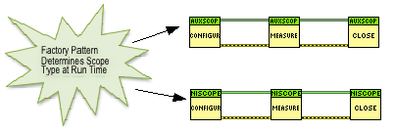

Integrating Into TestStand

The series of LabVIEW VI can also be called directly in TestStand. In this example sequence, each VI in LabVIEW is now a step in TestStand. Instead of wiring the object reference in LabVIEW, it is passed from step to step in TestStand through the LabVIEW Object reference.

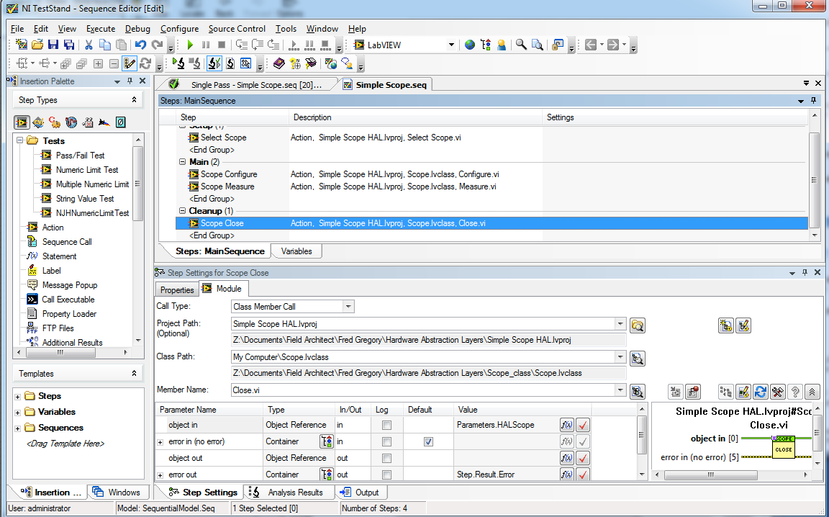

This Simple Scope.seq calls the same functions that are in the LabVIEW code. When designing and using a HAL, the team may chose to designate some people as developers of the HAL who will write and test the code in LabVIEW. Then the test team may leverage the HAL as they craft the overall test sequence and framework.

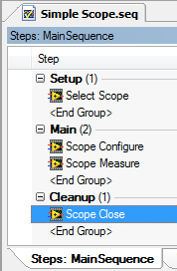

Note the call type. Just as in LabVIEW, TestStand is executing dynamic dispatch based on the object reference input to the Close.vi.

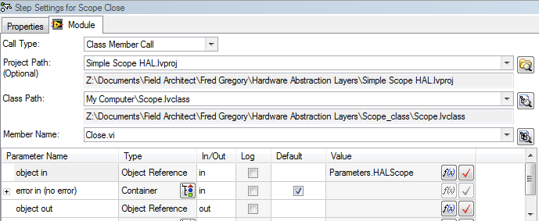

Summary:

LabVIEW and TestStand provide all the tools to easily create a HAL for use in simple and very complicated test systems. LabVIEW’s implementation of OO includes all of the key features of inheritance, such as dynamic dispatch, to implement a HAL. Additionally the design tools facilitate the development process. Then, the migration from coding the modules in LabVIEW and then rolling the code into TestStand is simple. No wrapper code needs to be writing. The LabVIEW/TestStand framework helps make the implementation side of the HAL as straight forward as possible.

Finally, the real challenge in writing a HAL in LabVIEW/TestStand is not the implementation, rather the design. The design team for a new tester, should take the time to learn OO

Appendix A – Design Decisions

HAL or MAL: Determine the appropriate interface. Is this a hardware abstraction layer or a more extensive measurement abstraction layer.

Ultimate Ancestor: Consider whether all types of instruments should inherit from an “Instrument” class or whether each independent instrument category should stand-alone. Defining an instrument class allows the user of the HAL to have an array of different instruments in LabVIEW. Additionally some common functionality such as self-tests and resets can be implemented at this level.

Leverage IVI Drivers: Consider whether or not to leverage IVI drivers. IVI drivers are a type of HAL. There are specific instrument classes, simulation options, and the ability to add specific functionality for instruments that have features that are not exposed by the instrument class. One options is to make the IVI driver the actual HAL. The work is already done. However, this does have hidden costs. For instruments that do not have IVI drivers, the cost of developing an IVI – compliant driver is significantly higher than creating a simple LabVIEW based HAL. Moreover, the developer is beholden to the interface defined by the IVI drivers.

Defining a Simulation Class: Consider having a simulation class and hardware class that inherit from the specific instrument class. Or if the solution is using IVI driers then a simulation class could use the IVI driver, even if it is wrapping the driver in a modified interface.

Also, the functionality of the simulation must be defined. It could be very simplistic, returning almost random data, or it could be very specific data that is determined by the unique configuration. Most importantly this should be considered at the definition phase of the HAL

Determine Class Private Data: What should be in the attributes of the class? Is this just the resource name? Does it also contain all of the settings of the instrument? Technically the settings of the instrument reside in the instrument. It is that global storage of the settings. So if the settings are also defined as attributes of the instrument class, then essentially, two copies will exist. There are use cases that do support this. Ideally, it may take extra effort to maintain this second copy, however, caching settings can be beneficial. Only changed settings are sent to the instrument, thus potentially saving the time of resetting values. Also, instrument settings may be determined by specific calculations. So the instrument may be taking measurements while a parallel section of code is simultaneously caching the new settings for the next measurement.

Determine the Granularity of the Methods for the Class: Should a DMM have one Configuration method that handles all options? Should it have a different method for several categories of configuration? Many examples show: Initialize, Configure, Measure, Close. To what degree should this expand? And are these names correct? Should “Measure” actually be “Read”?

Private Methods: Remember to include private methods as needed.

What are Expected Overrides for Additional Child Classes: Sometimes only one small feature needs to be changed and as such a child class might have only one override method. What are the expected changes that might be handled by this?

Determine the Owner: Most of the team will use the HAL. Someone should be designated as the owner who will maintain and fix bugs.

Determine Process for Team Development: If a HAL will be developed simultaneously by several team members, a process should be defined to minimize conflicts with Source Code Control.

Other Questions: Should project templates be created for new instrument classes? How will the HAL be distributed? VIMP?

Other random thoughts? – Ever a need to use the channeling pattern? What are the use cases of aggregation or association relationships?

